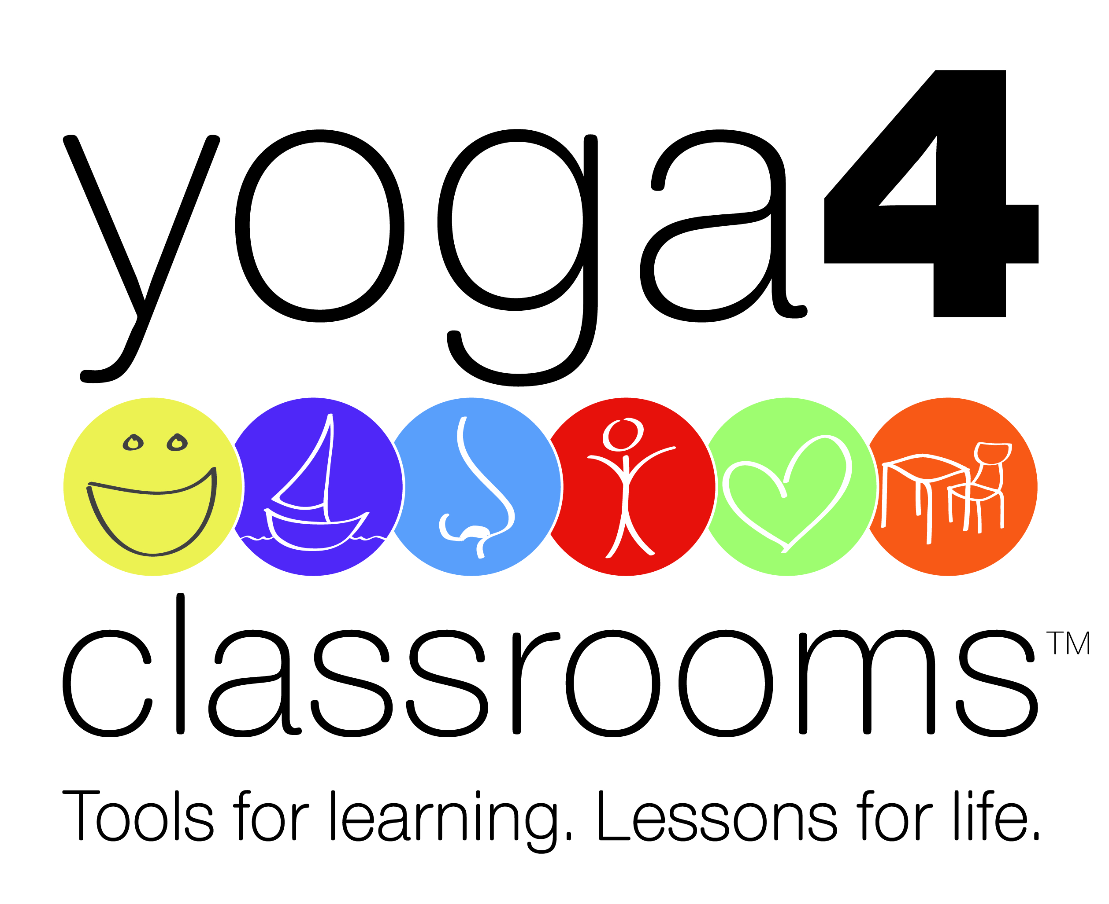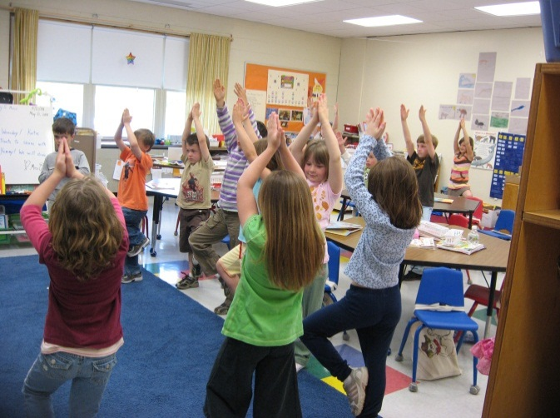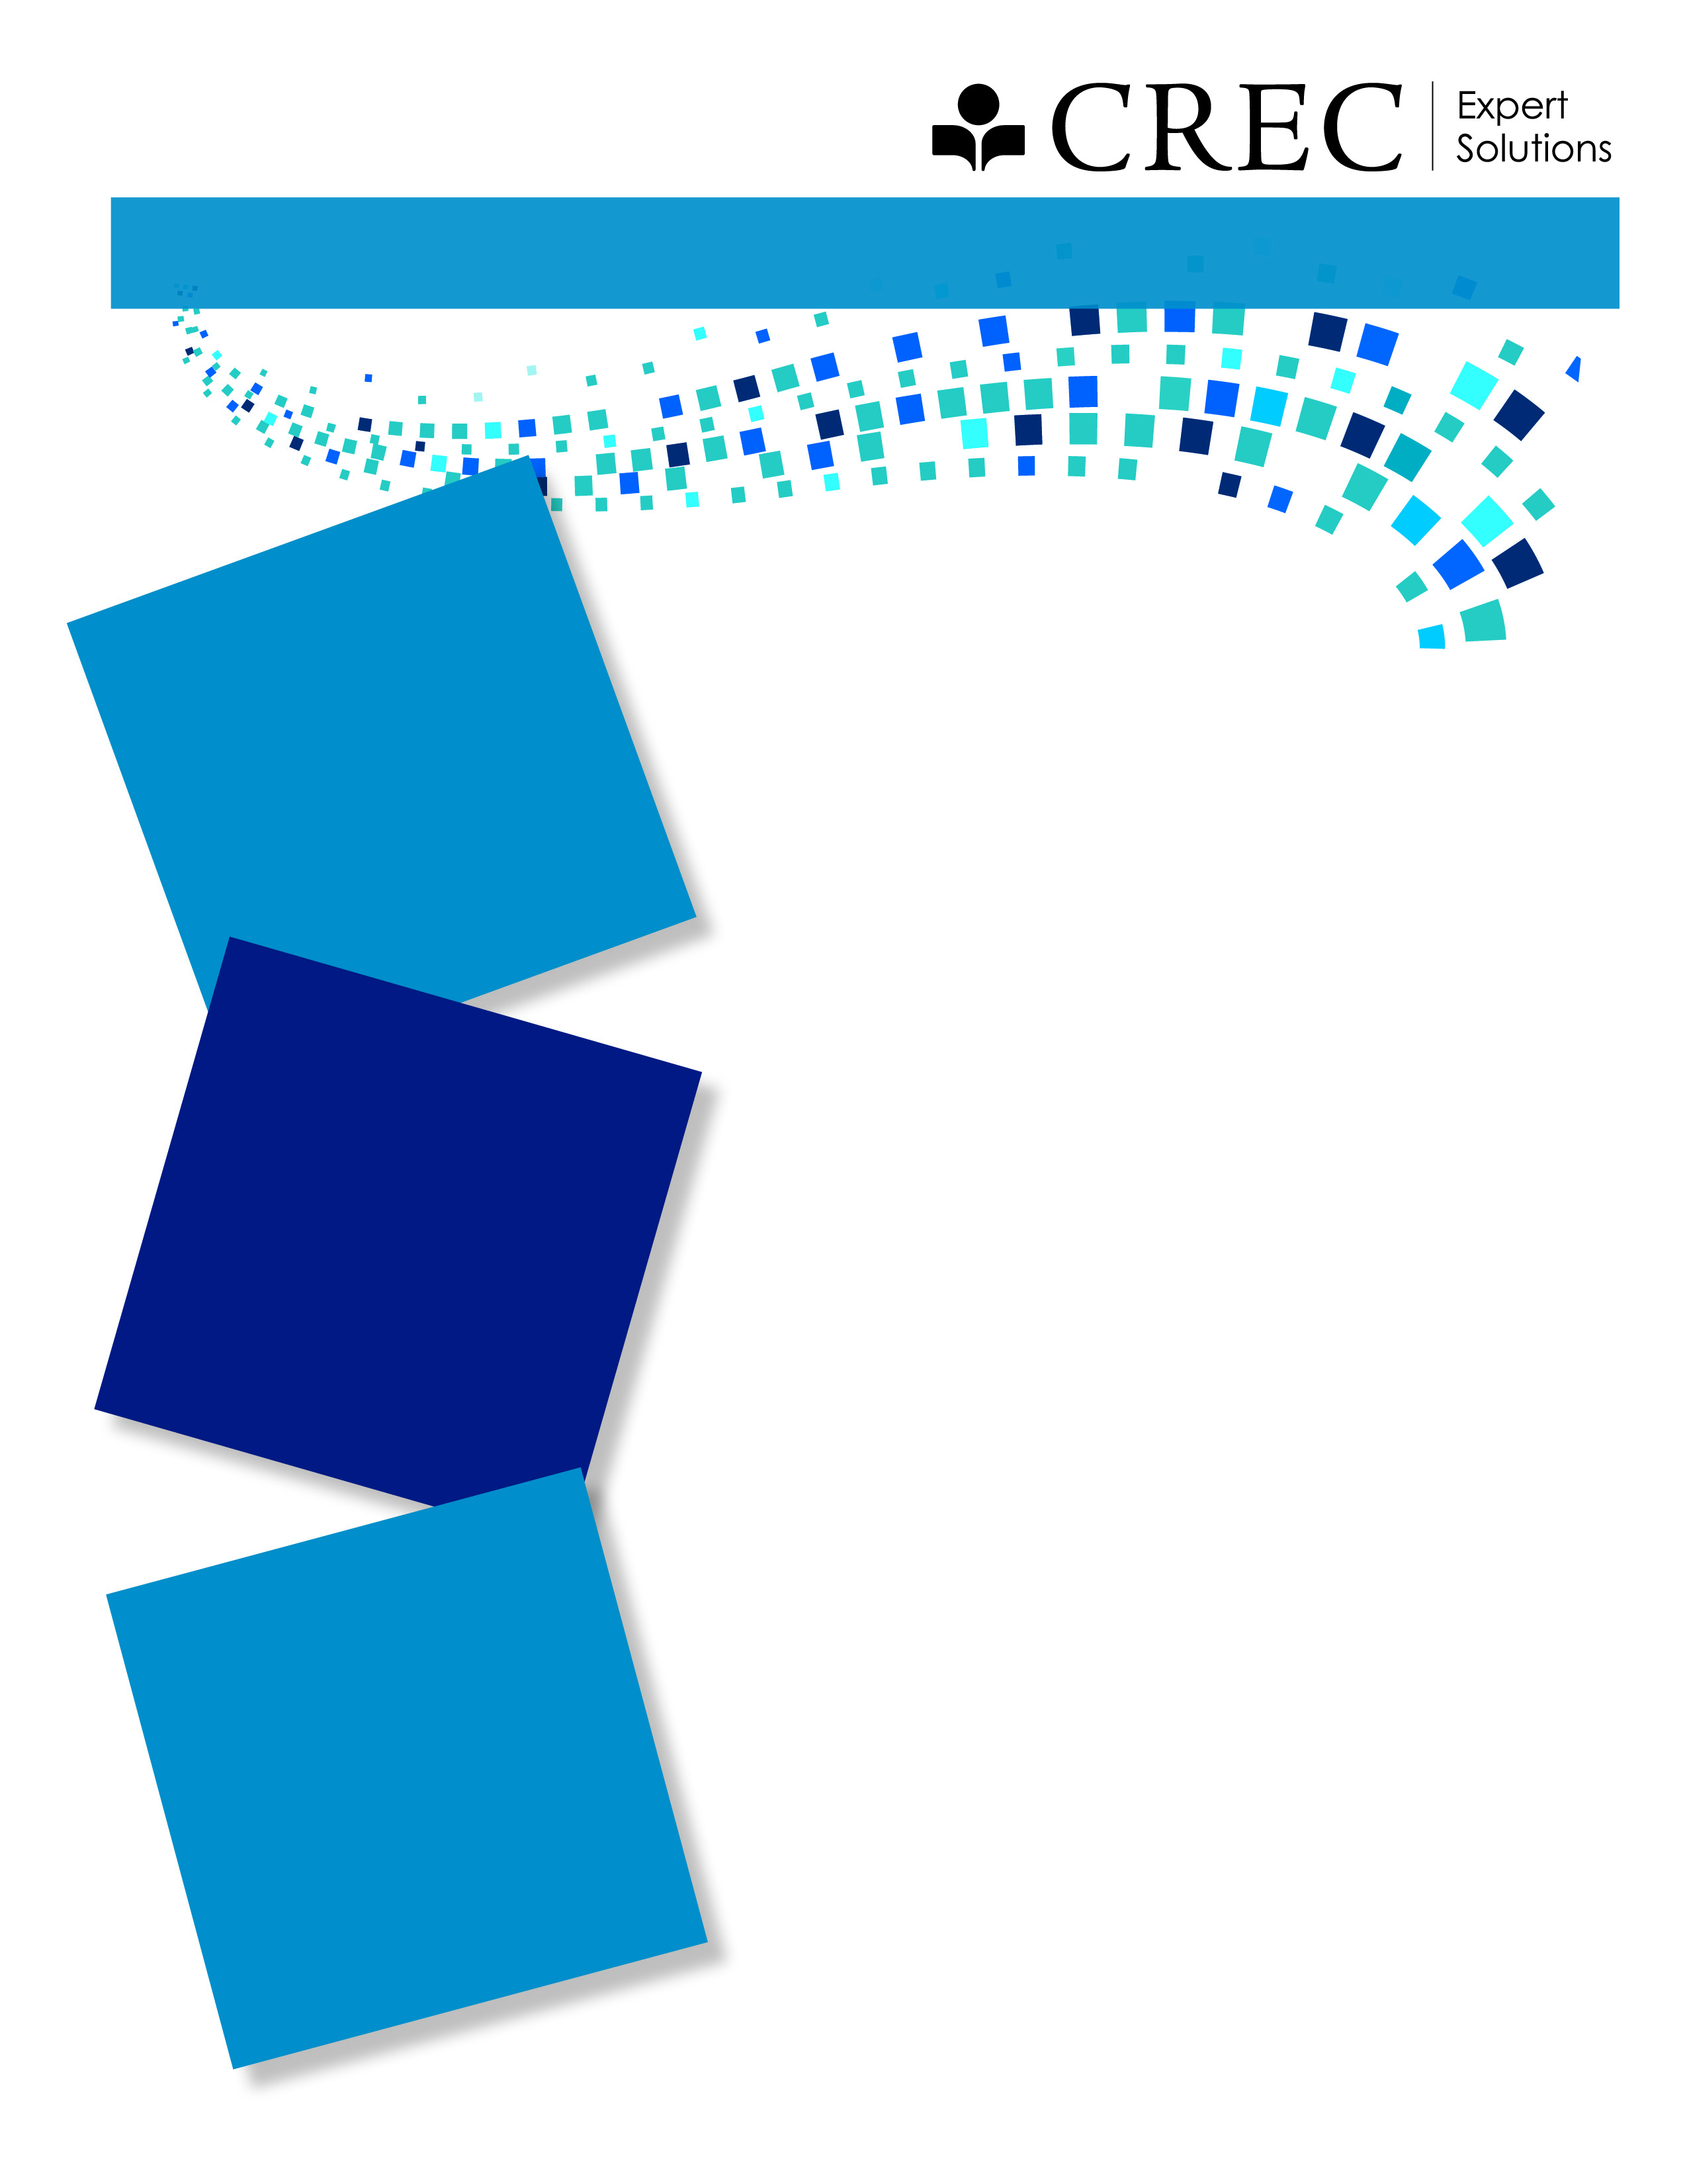

**$180 Cost Includes:**

* 6 hr. Interactive Workshop
* Fully-illustrated Yoga 4 Classrooms Teacher’s Guide
* Y4C Activity Card Deck
* Lunch

www.yoga4classrooms.com

This workshop will teach you how to use simple and effective yoga and mindfulness strategies ***throughout the day* *right in your classroom***. NO YOGA EXPERIENCE OR MATS required!

The Y4C program goal is to create peaceful, productive, **learning-ready students** and classrooms!!

For more information or to book a session in your school/district please contact:

**Emily Rosen at erosen@crec.org**

**860-509-3610**

**[REGISTER TODAY!](https://www.protraxx.com/scripts/ezcatalogny/ClassCatalog.aspx?CustomerID=128)**

**Tools for Learning. Lessons for Life.**

**Yoga 4 Classrooms®**

**NO YOGA EXPERIENCE OR MATS REQUIRED!**

**Audience:** K-12 classroom teachers, administrators, counselors, nurses, physical

and health education teachers, and therapists

[**Tues. July 29, 2014**](https://www.protraxx.com/Scripts/EzCatalogny/ViewClass.aspx?ID=304607&CustomerID=128)

**OR**

[**Sat. August 23, 2014**](https://www.protraxx.com/Scripts/EzCatalogny/ViewClass.aspx?ID=304608&CustomerID=128)

**AT CREC Coltsville**

**Hartford, CT**

Data, Analysis, Research and Technology (DART)

111 Charter Oak Avenue, Hartford, CT